### **Performance Comparison between View Dynamic Glass & Original Glazing at Harvard University Biological Laboratories**

By Christopher Bitzas, Energy Manager, Siemens, Harvard University

Quentin Gilly, Senior Coordinator, Office for Sustainability, Harvard University



## Executive Summary

This report presents the results of a side-by-side performance comparison between View Dynamic Glass (“**VDG**”), manufactured by View Inc, and the existing glass (“**Baseline**”) on the windows of Conference Room 1075 (“**1075**”) at the Harvard University Biological Laboratories (“**Bio Labs**”) building, located at 16 Divinity Ave., Cambridge, MA. The experiment was conducted in 2016 between July 28 & August 5, with the purpose of measuring the ability of View Dynamic Glass in maximizing occupants’ thermal and visual comfort, reducing cooling load, and increasing building energy savings. The analysis of recorded data shows that:

1. Temperatures of glass surfaces exposed to direct sun were 15 to 20°F cooler in the VDG room. Temperatures of the wood countertop were 10 degrees cooler.
2. With air-conditioning turned off, room 1075 temperature did not rise more than 79°F in the VDG scenario (with 70°F being the benchmarking set-point), whereas in the Baseline scenario, room temperature rose to a maximum of 82°F (78 °F vs. 80 °F in room 1077). This outcome has an immediate positive impact on the cooling systems at Bio Labs, which will need to work lesser with VDG on the windows, and thereby serve for a longer equipment lifetime, while reducing maintenance time & costs, and consuming less operational energy.
3. During the test period, no glare problem was noticed in either room. This may have to do with the presence of trees outside the windows, and also the time of the year when the test was conducted, based on the sun’s positioning. Blinds were not used in either glass scenario during this test period. It is expected that in the absence of shading elements outside the building, such as trees, direct sun will penetrate more deeply into the room and thus, the Baseline case will need blinds regularly. VDG manufacturer claims that occupants will not need to use blinds with VDG on windows, because of VDG’s very low Solar Heat Gain Coefficient (SHGC) and Solar Transmittance (Tsol). The validity of this claim will need to be assessed on one of View Inc’s other project sites.
4. During the times of the most direct sunlight the cooling coil control loop output was 10% to 20% less with the VDG installed.  That 10% to 20% reduction in cooling command to the valve results in a 2% to 6% savings in chilled water energy (BTUH).
5. VDG was able to exceed the threshold for required ambient light for xx% of the time.

## 

Figure : Location of Rooms 1075 and 1077 in Biolabs

## Test Site & Setup

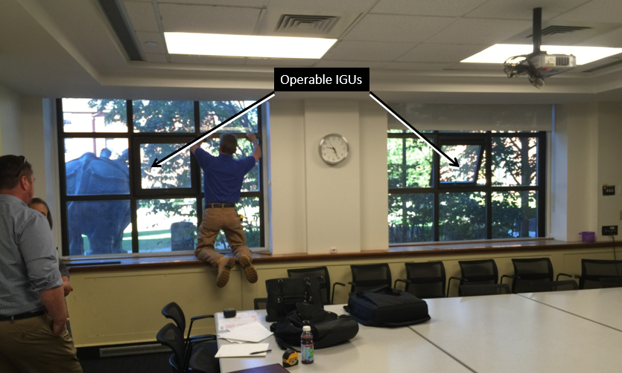The Biolabs building manager is a forward thinking individual who has lofty energy efficiency and building performance goals. After he learned about and contacted View Glass it was decided that Harvard and VDG would run a joint performance experiment of the glass in the Biolabs building.

Figure : Original Room Configuration Has 2 West Facing Windows

Room 1075 was the room chosen as the test subject. There were three primary reasons this room was chosen. Firstly, it was not going to be used in the summer so it was available for a test. Secondly, the room is served by two identically sized fan coil units (FCU). Thirdly, the room could be bisected to form two separate rooms of nearly equal dimensions (floor space and volume).

The plan was to use 1075, divided into 2, for the comparative test, with VDG on one side & the Baseline IGU on the other. The following steps were carried out towards preparation of the site for the experiment:

1. Room 1075 was divided by constructing a partition at the middle of the room. The wall was built by professional contractors. It was comprised of sheet rock, aluminum framing studs and R-11 insulation. The joints were carefully sealed to prevent air infiltration from one side to the other (Figure 3). The two new rooms would be come to known as rooms 1075 and 1077 (Figure 4).
2. Each room has roughly 220 square feet of floor space.
3. 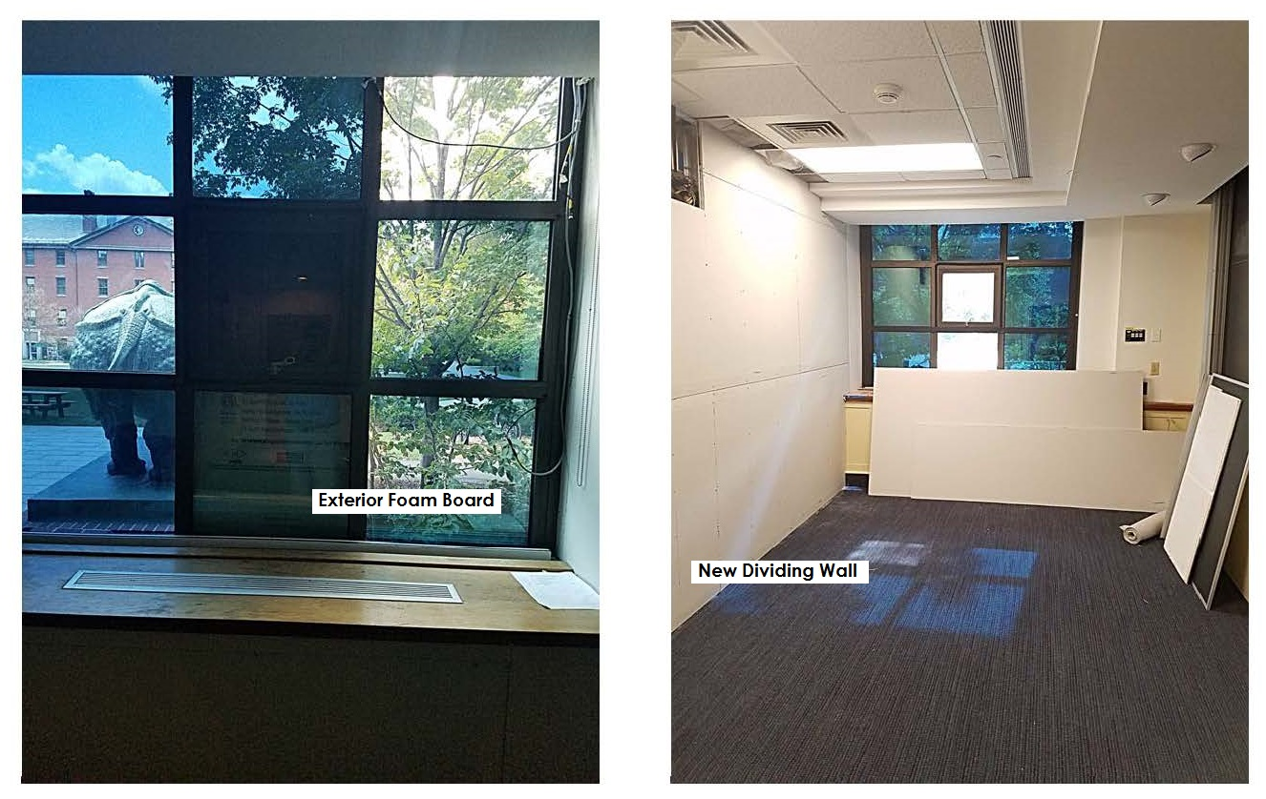Each room had a glazed window, with mullions splitting it into 9 insulated glass units (IGU’s) (Figures 2 and 3). The central IGU is operable and the lower middle IGU has a low emissivity film. These two IGUs were externally covered with a foam core board that has insulating properties.

Figure : Exterior Foam Board, 1075 Side (L), New Dividing Wall, 1077 Side(R)

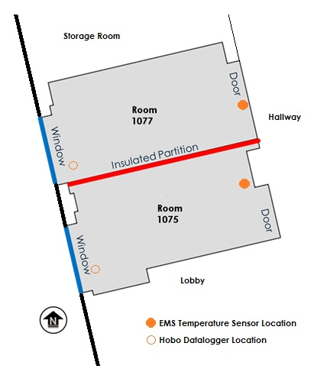

Figure : Diagram of Partitioned Room

1. The FCUs have a plenum return. In order to prevent return air from one room from mixing with return air from the other the plenum space was sealed above the new dividing wall. Heavy duty plastic sheets were fixed between the structural beam and the top of the dividing wall. Figure 5 shows a representation of the plenum seal.
2. The FCUs were already equipped with dedicated controllers for individual control. Each had its own temperature sensor and each had the same size valve on the chilled water coil. The valves are ½” bodies with floating control actuators on a ¾” copper pipe.
3. The experiment began with VDG in room 1077 and the Baseline IGU in room 1075.
4. Blinds were removed from the windows.
5. The lights were manually turned off for the entire experiment.
6. The doors were locked at all times
7. Data loggers, the Siemens Energy Management System (EMS) and the VDG equipment were all used to monitor the appropriate parameters for the analysis. An infrared camera was used to gather temperature data on the glass surface.

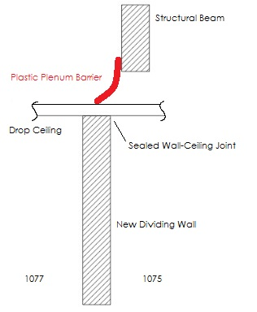

Figure : Sealed Partition Dividing the Plenum Space

## Metrics Monitored

1. Room air temperature, relative humidity and foot-candles were measured using devices from Onset Corporation’s HOBO Datalogger product line. See Table 1 for details.
2. The Siemens EMS trended 24 points related to the FCUs. See Table 1 for details.
3. The VDG equipment monitored the glass’ tint state and exterior radiation. See Table 1 for details.
4. Surface temperature: Measured using a FLIR IR camera.
5. Chilled Water Flow Rates: Neither FCU was equipped with a flow meter to track flow rates. The chilled water valve command signal was trended and correlated to flow rate via tabled data. The tabled data was established using an Onicon F-4400 portable ultrasonic flow meter. Flow rate data was recorded at valve commands that represented the most frequent trended commands and the entire range. A scatter plot and trend line of the data was used to calculate BTUH with the assumption that the coil performs at a constant 10 degree temperature differential. See Figures 5 and 6 for details.

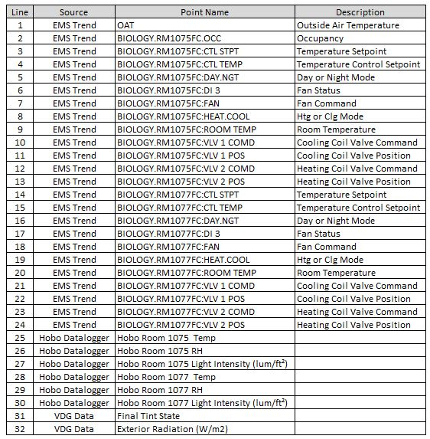

Table 1: Trended Points

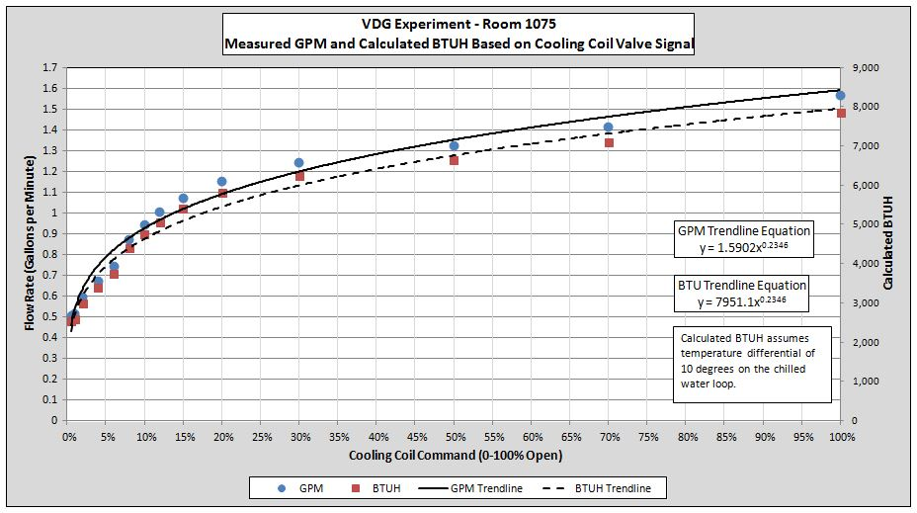

Figure : Room 1075 Cooling Coil Flow Rate Measurements and Calculated BTUH

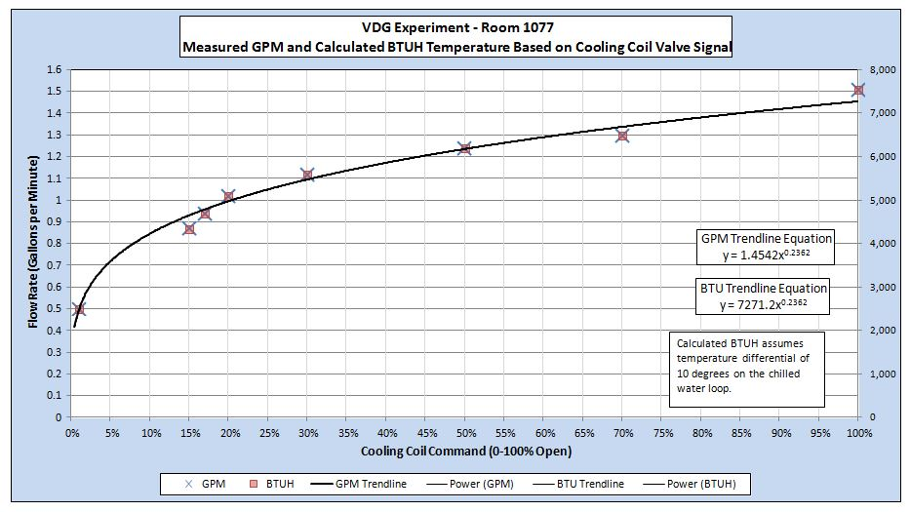

Figure : Room 1075 Cooling Coil Flow Rate Measurements and Calculated BTUH

## Methodology

The experiment, as it was originally intended, was to compare VDG to the Baseline IGU four different ways on a weekly basis. VDG would be installed on one side and the Baseline IGUs would be installed on the other. The first test would compare the VDG room’s FCU cooling control valve command (CCV) to the Baseline room’s FCU CCV. The CCV is the digital control loop output that commands the valve open or closed. The controlled parameter is the room temperature and the setpoint is the room temperature setpoint which was set to 70°F at all times. The second test would turn off the FCU fans and close the cooling valve in order to see how the room temperature in the VDG room compared to the Baseline IGU room. The third and fourth tests would be a repeat of tests one and two but with the VDG and Baseline IGUs switched from one room to the other. Table 2 summarizes the parameters and VDG location. It should be noted that the VDG was programmed to transition to full tint when direct sunlight was on the façade. There was no modulation from clear to dark.

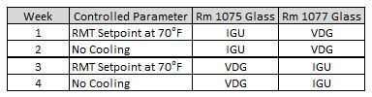

Table 2: Experiment Setup Summary

In ideal test circumstances, the two glazing types being compared would be installed in perfectly identical rooms, with the same room dimensions and configuration of windows, HVAC, lighting, etc. In the case of the Bio Labs building however, the comparative test was proposed to be conducted in an existing room, which was to be divided by a temporary insulated partition. The two halves thus created would have been similar but not perfectly identical. Moreover, there are trees and a rhinoceros sculpture on the outside, which shade the two windows differently (Figures 2 and 3). As a result, the glass in both windows was subject to variations (timing & intensity) in incident solar radiation. The FCU systems that served the two rooms would thus be exposed to varying conditions that are not caused by the window glass.

To overcome these variations and the potential unreliability of recorded data, the test was conducted in the four configurations described above. The intention behind running tests with both glass types (VDG and Baseline) being installed alternately in both rooms (1075 & 1077) was to maximize the potential for an unbiased test outcome. Similarly, running tests with the air-conditioning ON and OFF was intended to eliminate the potential experimental error due to the inherent differences in the efficiencies of the FCU systems in the North & South Rooms. The following section “Test Protocol” details the steps involved.

## Test Protocol

### Install Instrumentation

All instrumentation was installed as outlined in the “Metrics monitored” section above. Table 3 summarizes the dates, parameters and VDG location.

### Week 1 (July 28 – August 1): VDG in room 1077, with air-conditioning ON

1. View Glass technicians ensured that the glass in the room 1077 was commissioned and performing properly.
2. The baseline glass was installed in the 7 fixed IGU frames of the room 1075 window.
3. The thermostat was set to 70oF in both rooms. This set-point applied to both DAY MODE and NIGHT MODE in the FCU operational program.
4. The FCU was set to DAY MODE from 8am to 6pm. During the DAY MODE the fan was allowed to run continuously, regardless of the operation of the cooling coil valve.
5. The FCU was set to NIGHT MODE from 6pm to 8am. During the NIGHT MODE the fan cycled ON only when space called for cooling and the cooling coil valve was modulating open.
6. Electric lights were turned OFF for the entire test, all configurations.
7. Pretest period: This was a 2-day period preceding week 1, when rooms were allowed to operate with normal air-conditioning overnight. The test began the next day at 8 am. The rooms were not occupied during this period.

### Week 2 (August 3 – August 7): VDG in room 1077, with air-conditioning OFF

1. Pretest period: This was a 2-day period preceding week 2, when the rooms were allowed to operate overnight with air-conditioning turned OFF. The test began the next day at 8 am. The rooms were not occupied during this period.
2. The FCU fan was commanded OFF.
3. The FCU cooling coil valve was commanded closed.

### Week 3 (August 11 – August 18): VDG in room 1075, with air-conditioning ON

1. The glass was swapped between the rooms 1075 & 1077. VDG technicians commissioned the glass and ensured proper operation.
2. Pretest period: This was a 2-day period preceding week 3, when the rooms were allowed to operate overnight with air-conditioning turned ON.
3. The thermostat was set to 70oF in both rooms. This set-point applied to both DAY MODE and NIGHT MODE in the FCU operational program
4. The FCU was set to DAY MODE from 8am to 6pm. During the DAY MODE the fan was allowed to run continuously, regardless of the operation of the cooling coil valve.
5. The FCU was set to NIGHT MODE from 6pm to 8am. During the NIGHT MODE the fan cycled ON only when a room called for cooling and the cooling coil valve was modulating open.

### Week 4 (August 20 – August 25): VDG in room 1075, with air-conditioning OFF

1. Pretest period: This was a 2-day period preceding week 4, when the rooms were allowed to operate overnight with air-conditioning turned ON.
2. The FCU fan was commanded OFF.
3. The FCU cooling coil valve was commanded closed.

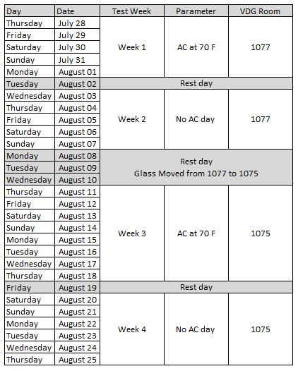

Table 3: Experiment Schedule

## Analysis of Recorded Data

The initial analysis of the trended data immediately revealed that uncontrollable variables, such as tree shading, had a substantial effect on the rooms in different ways. To eliminate and reduce the effect of uncontrollable variables on the results the analysis plan needed to be revised. The experiment would use the data gathered in the fashion outlined in Table 2 but use it differently. The analysis would now compare each room’s performance with VDG to its own performance with the Baseline IGU (Table 4).

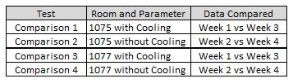

Table 4: Revised Analysis Approach

The experiment took the form depicted in the diagram in Figure 8. In addition to tree shading the uncontrollable variables included heat conducted from adjacent spaces, heat conducted from a steam main that serves the labs on the upper floors as well as the outside air temperature and solar radiation.

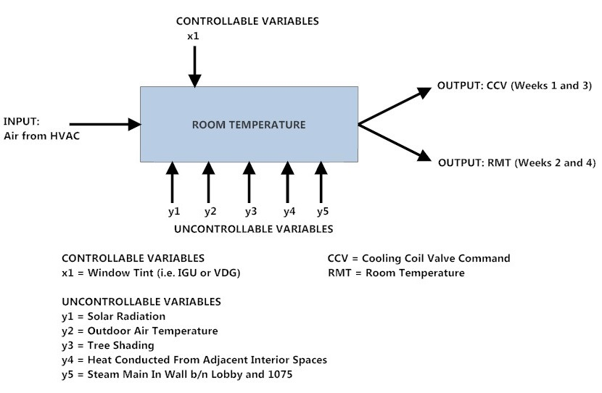

Figure 8: Diagram of Experiment

**Important Note Regarding Experiment**

Sunlight fell directly on the façade of the building from, on average, from 12:15 pm to 7:35 pm every day of the experiment. The times of most direct and unobstructed sunlight on the windows of 1075 and 1077 were between roughly 12:15 pm am 2:30 pm. After approximately 3pm the sun was at position such that the trees stood directly between it and the experiment. Room 1077 is subject to more shading than 1075 because it is position behind the trees on the building’s façade.

### Initial Results

Upon completion of the experiment the data was analyzed with the intent of comparing room 1075 to room 1077 on a weekly basis with various changes to parameters (e.g. cooling enabled/disabled and VDG/IGU). Refer back to Table 2 for details.

The data analysis for the Week 1 and Week 2 comparisons produced graphs that the team generally expected to see. In Week 1 the hourly average CCV for the VDG room (1077) was consistently and substantially less than the corresponding IGU room (1075) point (Figure 9).

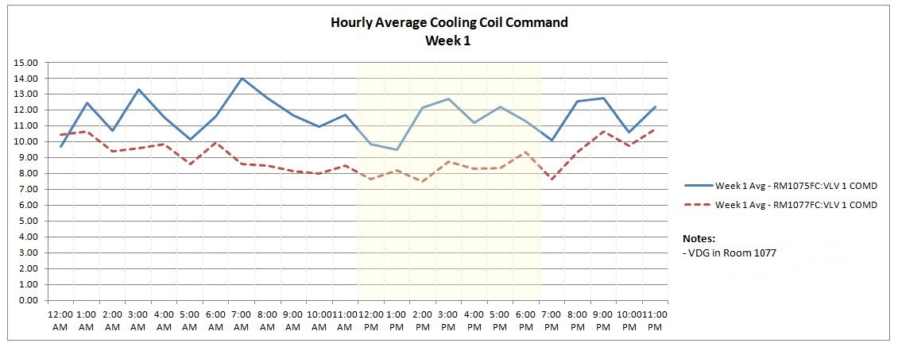

Figure 9: Week 1 Hourly Average Cooling Coil Valve Command

In Week 2, with the cooling disabled, the hourly average room temperature in the VDG room was less than it was in the IGU room; however the difference during the times of direct sunlight wasn’t as large as the team was expecting to see. However the Hobo Dataloggers which were recording the air temperature on the surface in front of the window did show a substantial differential between the test and baseline cases (Figure 10). The section of the graph that was concerning lay during the times of no sunlight at all and particularly during the early morning hours when one could presume that most of the heat absorbed by the building had dissipated. During these times Room 1075 was consistently warmer than Room 1077 by approximately 2 °F.

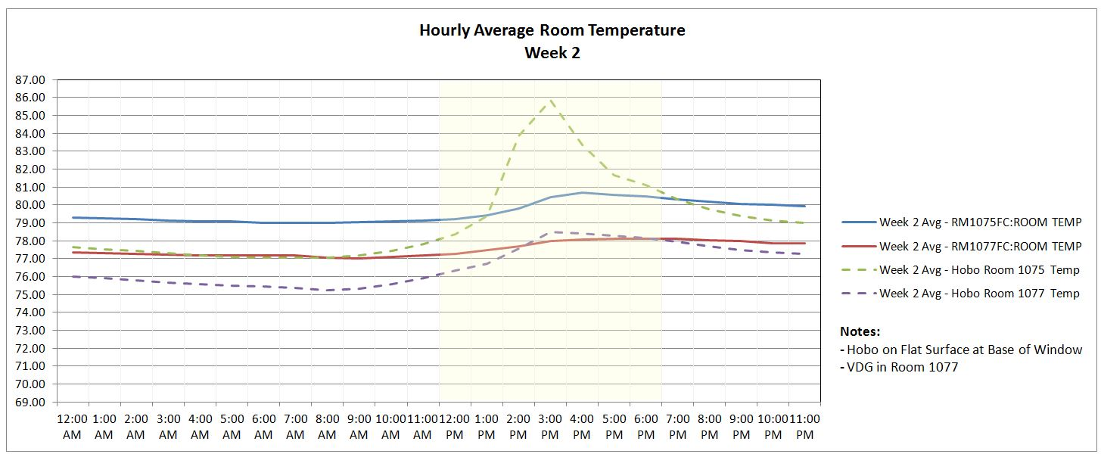

Figure 10: Week 2 Hourly Average Room Temperatures

The team’s concerns about the 2 degree differential were compounded with figures 11 and 12. These figures are graphs of data after the VDG was moved from 1077 to 1075. During Week 3, with the cooling enabled, the CCV in 1075 is still higher than in 1077 even though the VDG has been moved (Figure 11).

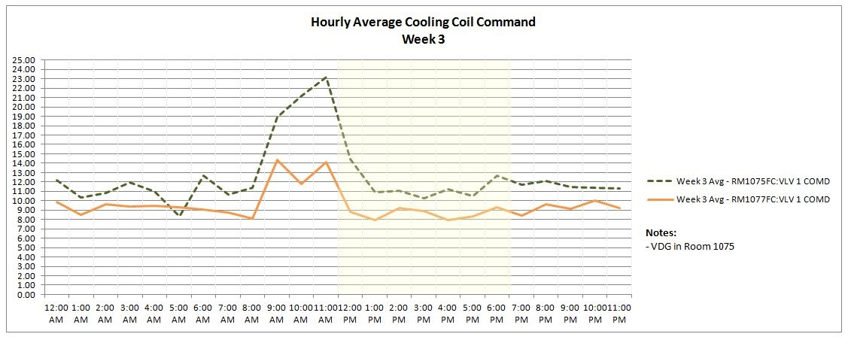

Figure 11: Week 3 Hourly Average Cooling Coil Valve Command

Similarly, during week 4 when the cooling is disabled the temperature is still higher in 1075 as seen in Figure 12. Figure 12 also displays the effect of the tree shading. The Hobo Dataloggers show a large temperature differential during the time of most direct sunlight. However, when the sun moves behind the trees the surface temperature actually decreases and changes direction so that the VDG room surface temperature is actually warmer than the IGU room surface temperature.

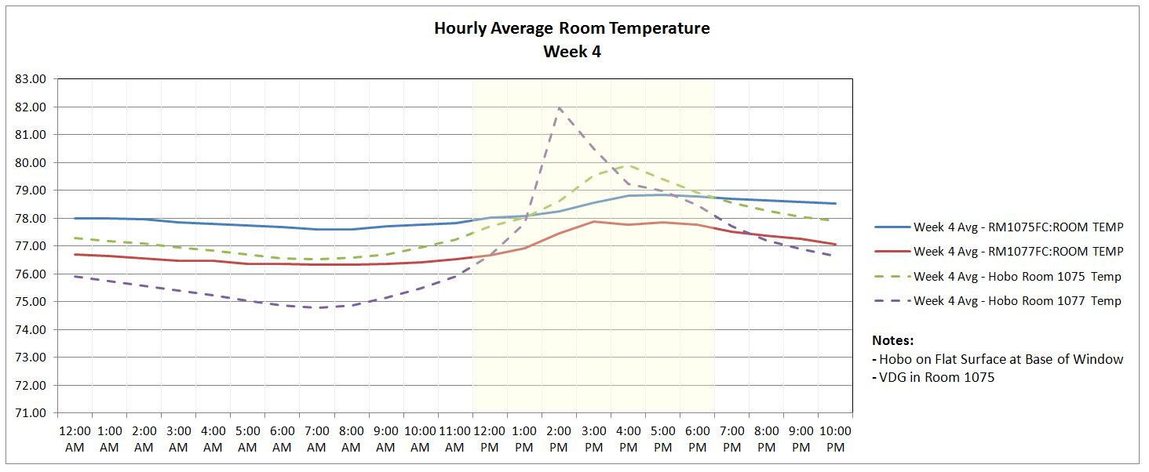

Figure 12: Week 4 Hourly Average Room Temperatures

The data clearly displayed results that prohibited the team from comparing 1075 to 1077 on a weekly basis and the analysis approach needed to be revised. It was decided that each room with VDG would be compared to itself with IGU as shown in Table 4.

### Revised Analysis Approach Results

Climatic Conditions

In order to better understand the data analysis of the revised approach it is important to have a general idea of the differences in climatic conditions among the weeks. There are two uncontrollable variables related to the weather: outside air temperature (OAT) and external radiation. The two are not necessarily correlated in a way that makes it simple to normalize the CCV and RMT results. That being said OAT and external radiation load from among weeks should be considered when drawing conclusions.

The following figures, 13 and 14, display the hourly average external radiation (W/m2) and hourly average outdoor air temperature. The graphs in Figure 13 shows week 3 had a higher hourly average OAT as well as a higher hourly average external radiation than week 1. This shows that both uncontrollable climatic variables provided a higher cooling load in the second week of the CCV comparisons. The graphs in Figure 14 show that week 2 was warmer but week 4 had a higher radiation load.

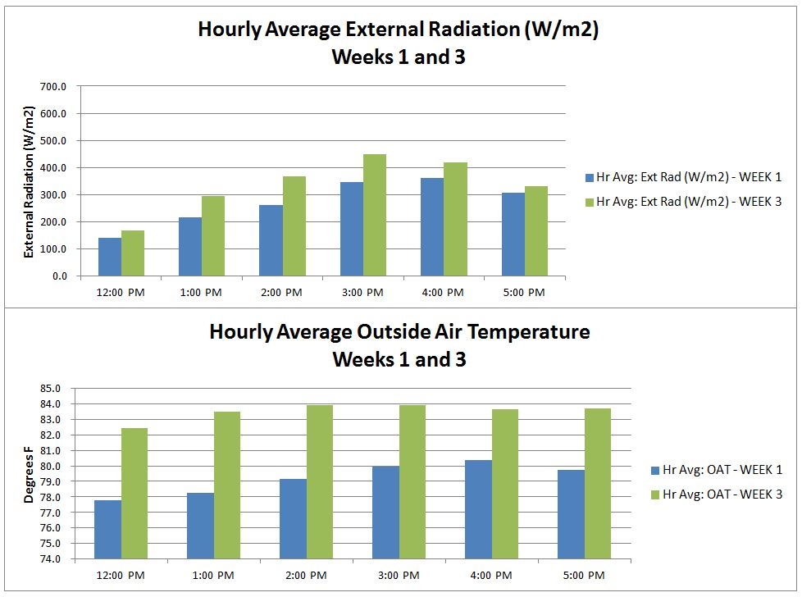

Figure 13: Weekly Comparison of Hourly Average Exterior Radiation and Outside Air Temperature, Weeks 1 and 3

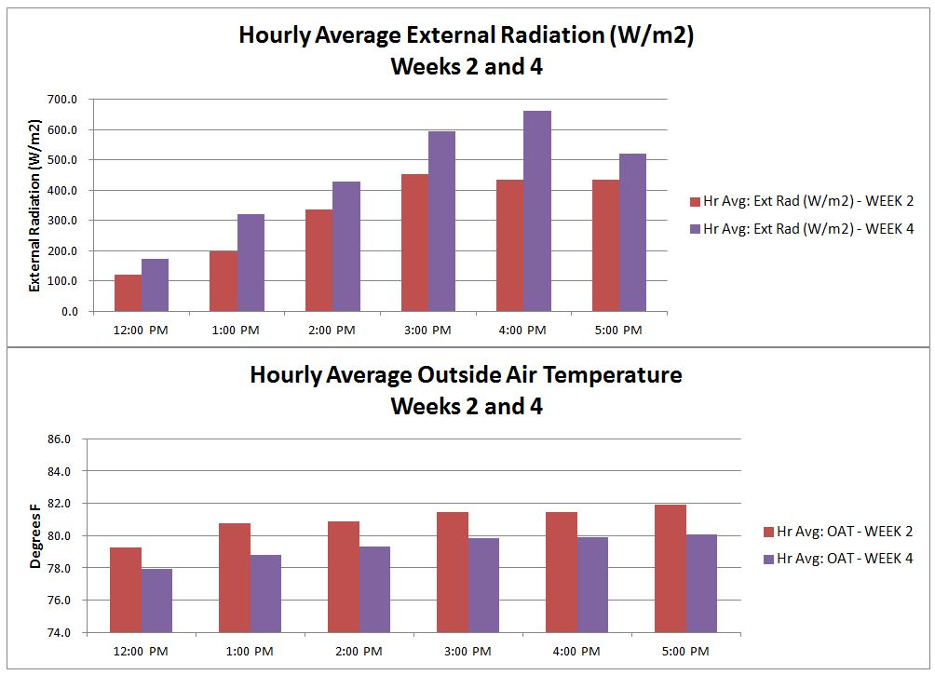

Figure 14: Weekly Comparison of Hourly Average Exterior Radiation and Outside Air Temperature, Weeks 2 and 4

Figure 15 displays the hourly average OAT and hourly average external radiation by week. It can be seen that higher OAT do not always positively correlate to higher external radiation. This reinforces that OAT and external radiation can influence the CCV and RMT results differently.

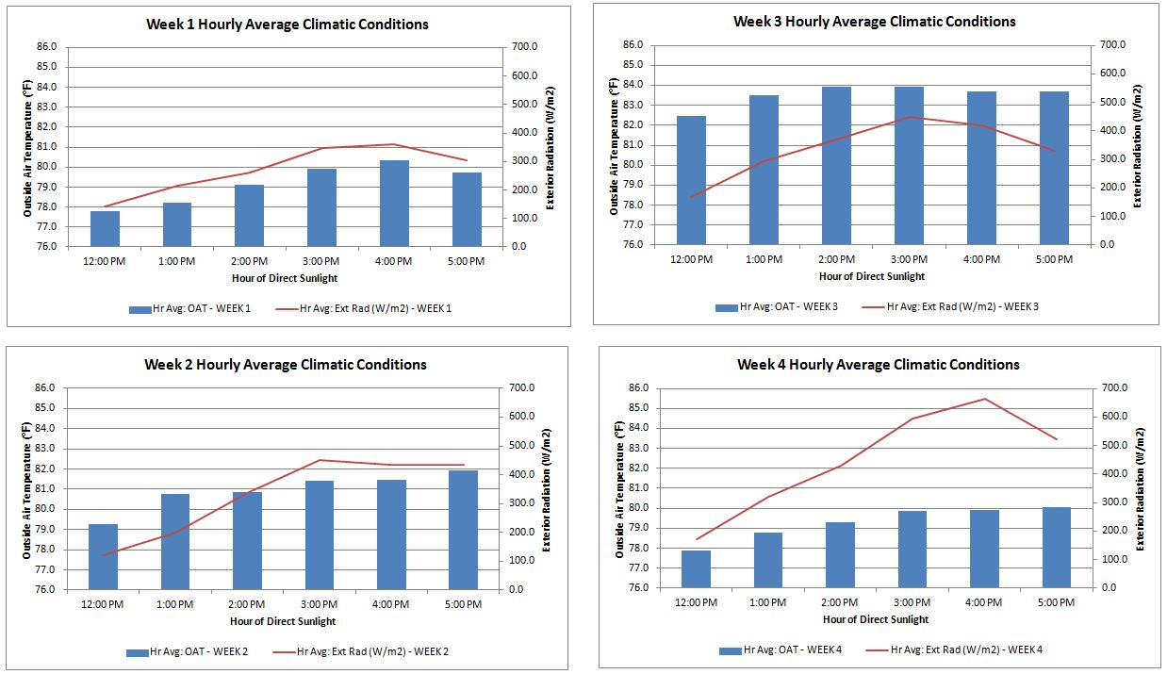

Figure 15: Hourly Average Outside Air Temperature and External Radiation by Week

Room 1075 Results

The windows in 1075 are partially behind the trees. There is also a large bronze rhinoceros statue in front of the left side of the window. Room 1075 is the room adjacent to the lobby. It was reported, by building staff, that the lobby runs hot all year long. After the experiment was finished the team learned that a steam main is enclosed in the wall shared with the lobby. Steam is provided to the labs on the upper floors all summer long. These uncontrollable variables certainly had an effect on the CCV and RMT results; they explain why 1075 runs 2 degrees warmer than 1077 when the cooling is disabled. Consequently, the higher cooling load would mean the FCU cooling coil would require more chilled water which would explain the valve being commanded more open when compared to 1077.

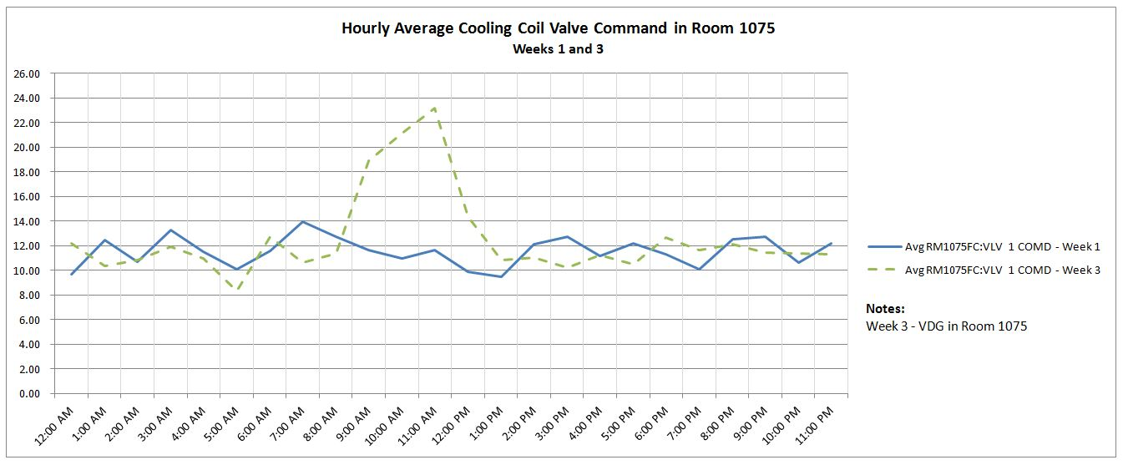

Figure 16: Room 1075 Hourly Average CCV Comparison, Week 1 to Week 3

Figure 16 displays the hourly average CCV in Room 1075 for the VDG (Week 3) and IGU (Week 1) test cases. The chart shows a spike in Week 3 CCV starting at 9:00am; recall that week 3 had a higher hourly average OAT and external radiation. At noon, the average temperature was 5 degrees warmer in week 3 so when the VDG began to tint, at about 12:15 pm, the room had a higher cooling load. Therefore there was a negative differential however, before 2pm the VDG has reduced the cooling load well enough that the hourly average CCV fell below the corresponding value for the IGU. The team concluded that despite the greater cooling load the VDG had a positive impact and reduced the CCV command for the FCU cooling coil.

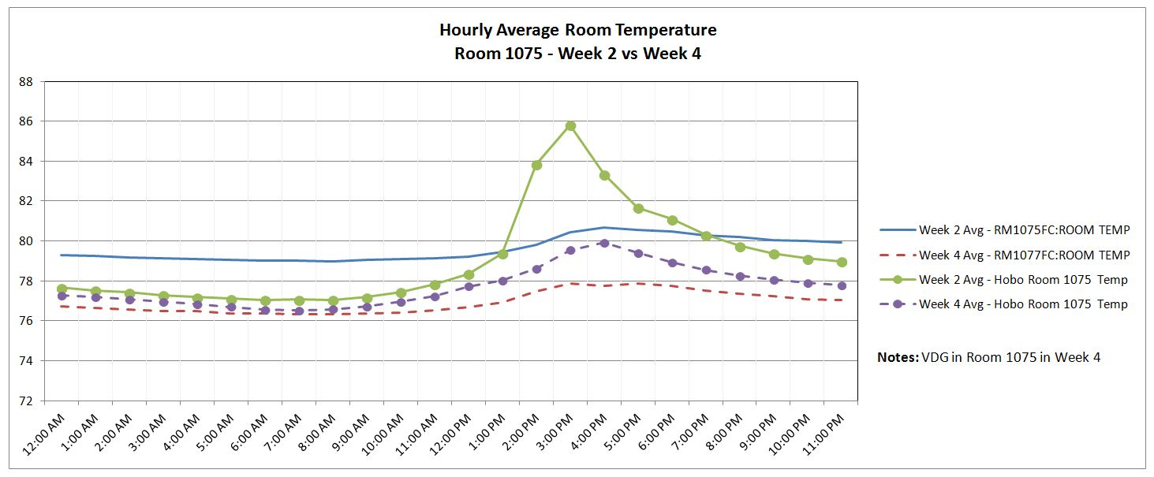

Figure 17: Room 1075 Hourly Average Room Temperature Comparison, Week 2 to 4

Figure 17 displays the hourly average RMT and Hobo Datalogger room temp in Room 1075 for the VDG (Week 4) and IGU (Week 2) test cases. The VDG test data for both EMS and Hobo Data is represented by the dashed line. The Hobo Datalogger lines have circle markers. The VDG has a substantial effect on the countertop air temperature, as measured by the Hobo Datalogger. The second full hour, the 2pm bin, show a stark increase in Week 2 to Week 4 differential. The differential peaks in the next hour then it gradually decreases. The team believes this decrease is due to the heaving shading that occurs after 3pm.

The RMT sensor is located opposite of the windows so the data is not subject to large swings like the Hobo Datalogger which was in direct sunlight. Neverthelss, the RMT saw an increase in Week 2 to Week 4 differential after in the second full hour of direct sunlight. That being said the differential did not change that much; it increased by 0.7 degrees. During the night and during the day when the sun was not directly on the façade the Week 2 to Week 4 RMT differential was consistently 1.3 degrees which is consistent with the hourly average OAT differential during that same time frame, 1.4 degrees. The team concluded that the VDG did reduce the temperature of the room but the data was muddled by the OAT and external radiation differences between the weeks.

Table 5 displays tabular data from Figures 16 and 17 for the hours of highest external radiation and the quantified difference.

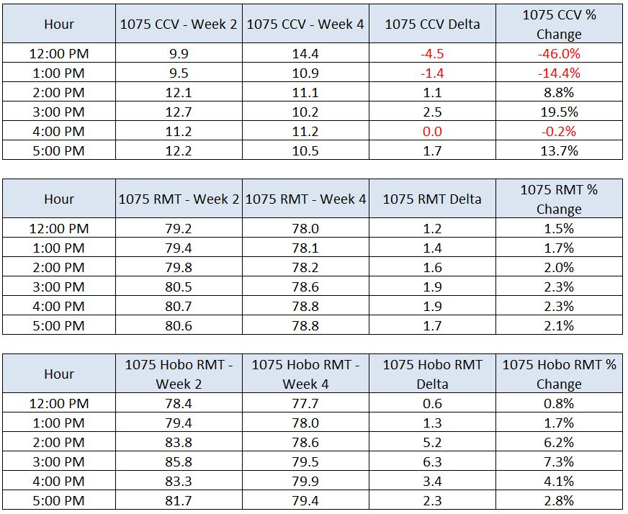

Table 5: Room 1075 Cooling Coil Valve Command and Temperature Differentials

Room 1077 Results

Room 1077 is the room further from the lobby up the tree line. The windows have nearly uniform tree coverage. The position of the trees and the path of the sun left 1077 partially or completely shaded far more often than 1075. The conditioned storage room adjacent to 1077 was rarely occupied and did not contribute any variation in the data.

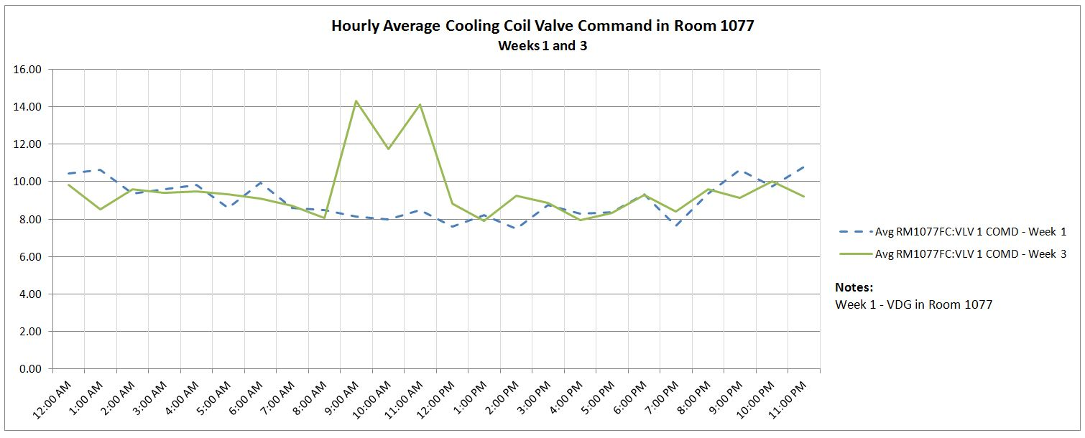

Figure 18: Room 1077 Hourly Average CCV Comparison, Week 1 to Week 3

Figure 18 displays the hourly average CCV in Room 1077 for the VDG (Week 1) and IGU (Week 3) test cases. The chart displays data that follows the same general pattern for the 1075 CCV comparision. The chart shows a spike in Week 3 CCV starting at 9:00am due to the warmer Week 3 temperature. When the VDG begins to tint the room is under a higher cooling load therefore, like Room 1075, there was a negative differential before 2pm and a positive differential after that hour. As with Room 1075 the team concluded that despite the greater cooling load the VDG had a positive impact and reduced the CCV command for the FCU cooling coil.

Figure 19 displays the hourly average RMT and Hobo Datalogger room temp in Room 1077 for the VDG (Week 2) and IGU (Week 4) test cases. The VDG test data for both EMS and Hobo Data is represented by the dashed line. The Hobo Datalogger lines have circle markers. This data shows that the VDG’s effect on the countertop air temperature is similar ot the resutls of the 1075 comparision, however at a smaller magnitude and for a shorter duration.

The EMS RMT data shows that there is no appreciable difference between Week 2 and Week 4. The hourly average room temperature differential ranged for -0.1% to -0.8%; effectively no change. Figure 19 shows that the RMT differential is virtually a constant throughout the day. As a result team concluded that the shading effect of the trees was far more substantianal than anticipated and negated any benfit of the VDG to the HVAC system. However the Hobo Datalogger results still showed a benefit to occupant thermal comfort.

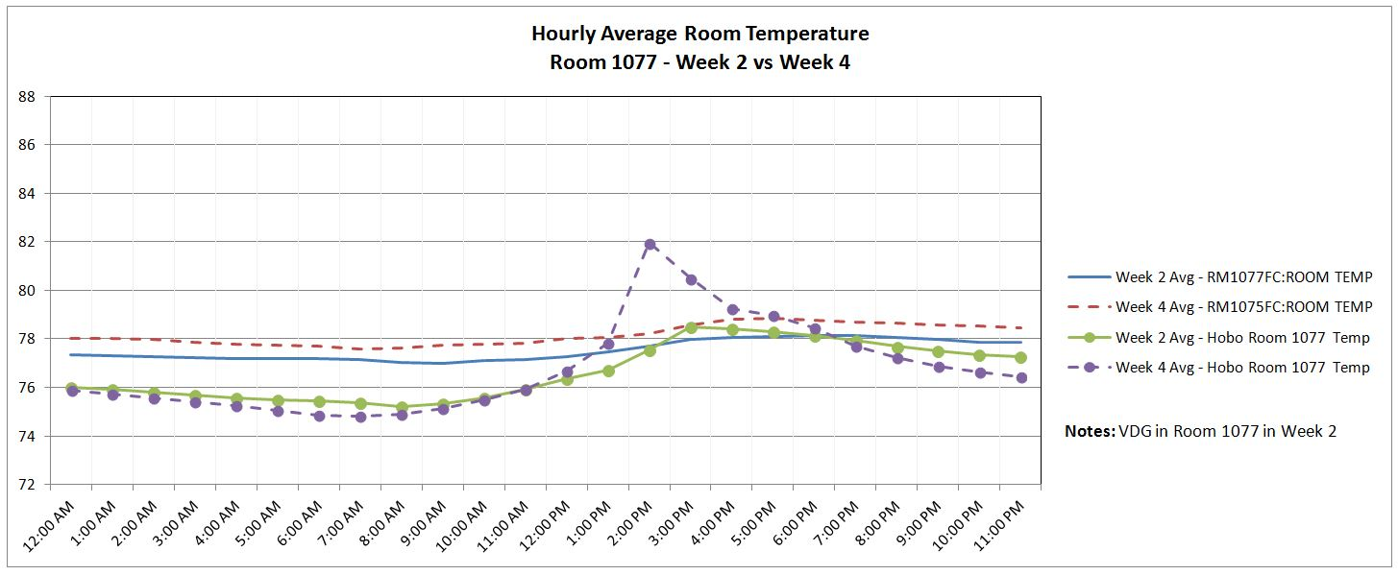

Figure 19: Room 1077 Hourly Average Room Temperature Comparison, Week 2 to 4

Table 6 displays tabular data from Figures 18 and 19 for the hours of highest external radiation and the quantified difference.

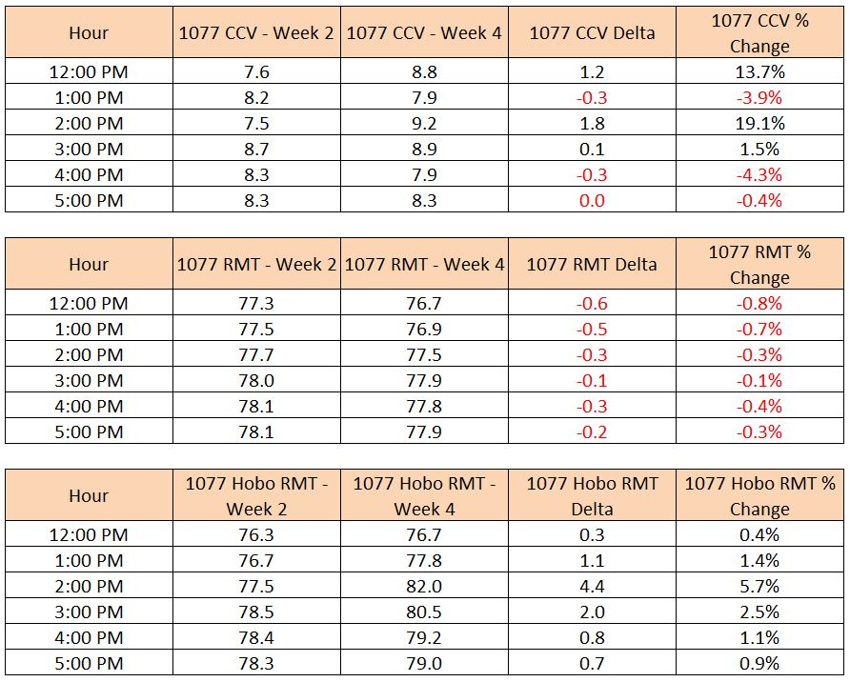

Table 6: Room 1077 Cooling Coil Valve Command and Temperature Differentials

Surface Temperature

The glass and countertop surface temperature data recorded by the FLIR IR camera show a stark difference between the VDG and IGU. The IR camera was used to take the surface temperature for each individual pane of glass in order to get an average with the entire window (panes behind the foam board were not included). The surface temperature of the wooden countertop in front of the window was also recorded. This data represents the temperature of a workspace that might be in similar position.

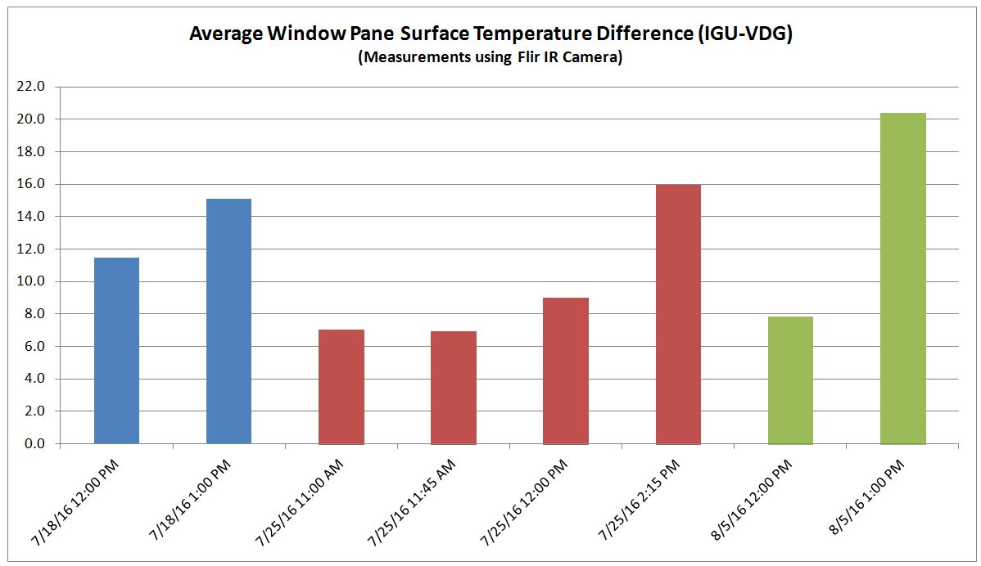

Figure 20: Window Pane Surface Temperature Differentials

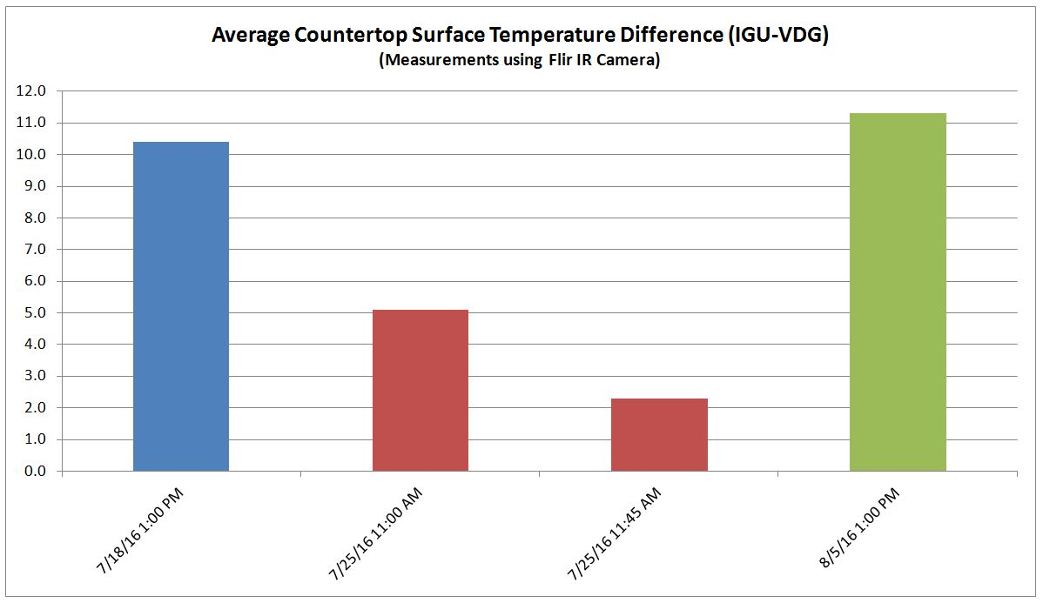

Figure 21: Window Pane Surface Temperature Differentials

Light Intensity

Light intensity reduction was not the focus of the team’s analysis. That being said, it is interesting to see how well the VDG does in blocking visible light from entering the room. Figure 22 shows the differential in lighting intensity between the VDG and Baseline IGU on a weekly basis. Tree shading is not corrected for in this data.

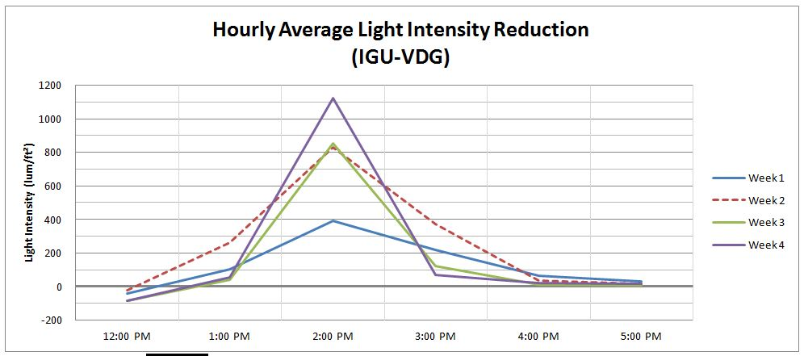

Figure 22: Hourly Average Light Intensity Reduction by Week

Conclusions

The team concluded that VDG will in fact save energy, save money and make the room more comfortable. Naturally it works best under ideal conditions with large, long exposure to direct sunlight. Interestingly, the shading effect of the trees was so substantial it had a noticeable effect on the RMT and Hobo Datalogger temperature data.

Table 7 summarizes the RMT and CCV results of the experiment along with the corresponding OAT and external radiation. The data shows that the VDG performs very well under ideal conditions but even partial shading begins to mitigate the HVAC reduction benefits of the technology.

While this experiment was performed under circumstances that were far from ideal it was tremendously beneficial because of the lessons learned from a practical application. The team expected the VDG technology to work under good conditions. However, gaining an understanding of the performance under less than ideal conditions (e.g. tree shading) provided valuable insight for building stakeholders. It is also important to note the effect of other uncontrollable variables such as heat transfer from adjacent spaces or equipment. The cooling load of room 1075 was artificially high due to its proximity to internal building heat loads; warm lobby and steam main. This load also diminished the effectiveness of the VDG technology.

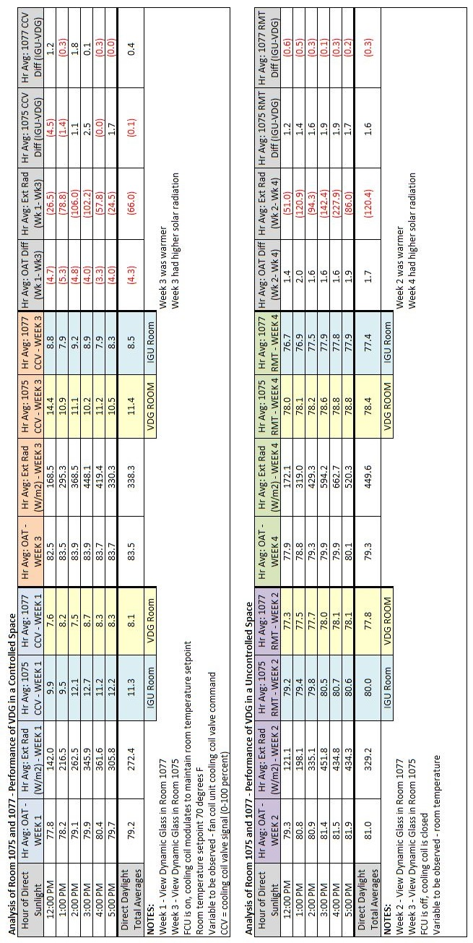

Table 7: Experiment Data Summary

Even considering the detractors just discussed, the VDG was able to reduce the load on the FCUs at various times. Figure 23 shows the BTUH differential associated with each FCU’s CCV. The gallons per minute (GPM) trend line equations from Figures 6 and 7 were used to calculate BTUH for the hourly average CCV for each room. The calculation assumed the coil has a temperature drop of 10 degrees. Note that this data is raw data and not normalized for any factors such as OAT or external radiation.

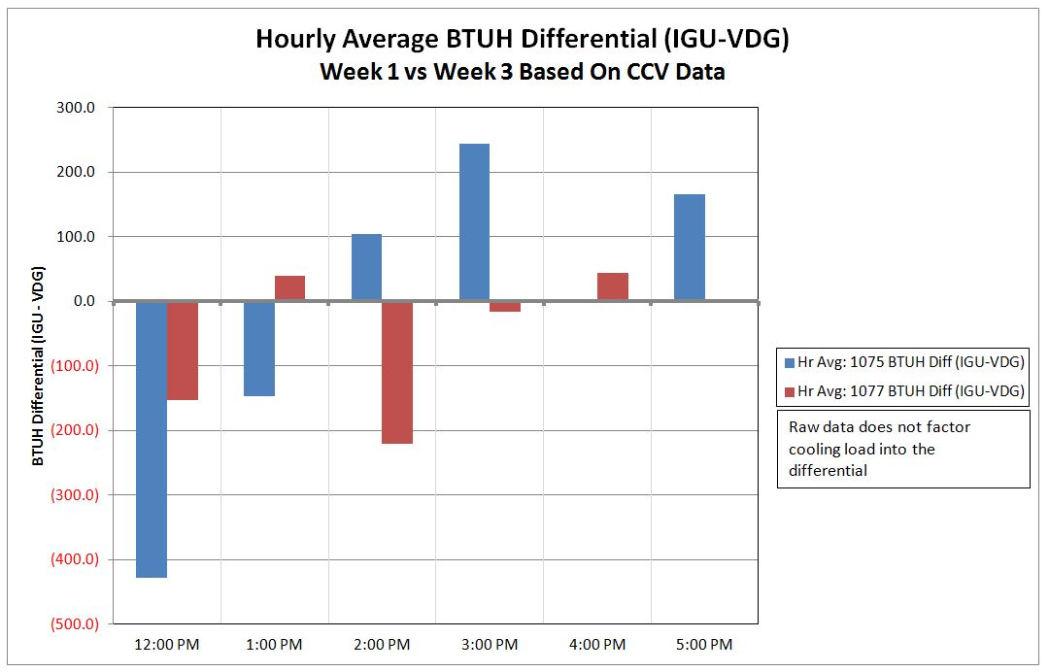

Figure 23: Hourly Average BTUH Differential Based on Cooling Coil Command Data (Baseline IGU – VDG)

The lighting intensity reduction results were as expected. Table 8 displays the hourly average lighting intensity reduction data seen previously in Figure 20.

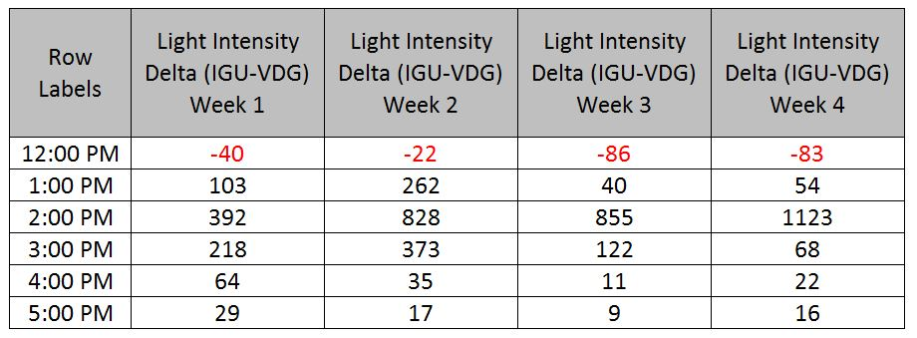

Table 8: Lighting Intensity Reduction

Lighting intensity was not a variable that the team was overly concerned with as the focus was on HVAC load reduction. However, it was beneficial to be able to quantify the reduction for the stakeholders and show them the reduction first hand.

The surface temperature data also yielded the results the team expected to see in the general sense. However, to see the order of magnitude that was reached in some instances was a bit surprising. The data shows that after 1pm the differential exceeds 14 degrees. The countertop temperature differential data followed the same pattern, exceeding 10 degrees after 1pm. Again, these variables were not the outcomes focused on by the team but having quantifiable data for stakeholders is valuable.

### APPENDIX

Hours of Direct Sunlight

The durations for which direct sun was incident on the test room windows is logged in Figure 24 below. It must be noted that in reality, due to the presence of other buildings on the West and North of test room windows, the sun stopped falling on the windows 2-3 hours before sunset. Figures 25 and 26 help explain how the start and end times were determined.

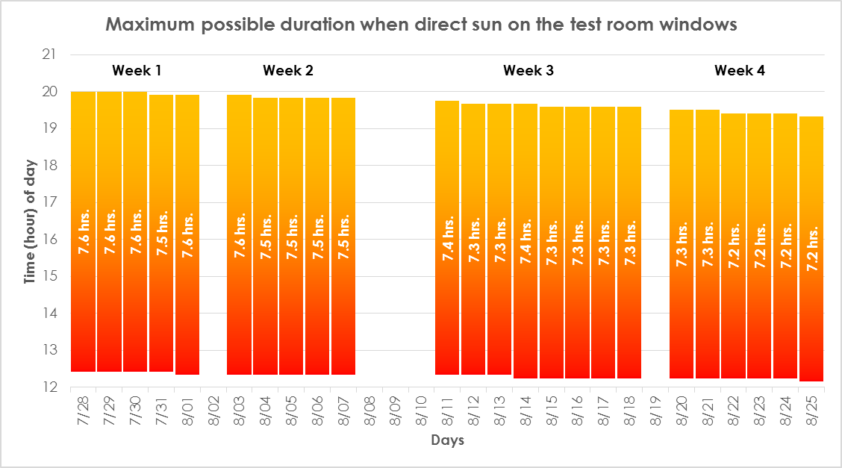

Figure 24: Duration when direct sun was incident on test room windows. Lower bound depicts the start time when sun enters the façade, while the upper bound of each day represents the sunset time..



Figure 25: Solar azimuth indicates sun’s position along the cardinal directional plane, whereas solar altitude indicates sun’s elevation in the sky. Above figure shows the example of July 28, the time depicted being 12:20 PM. The solar azimuth is parallel to Bio Labs building’s West façade, making 12:20 PM the “start time”.



Figure 26: Similarly, the above figure shows sun’s position at sunset (8:00 PM) on July 28. Direct sun may have stopped hitting the test room windows (located by the red circle) 2-3 hours before sunset.

Histograms

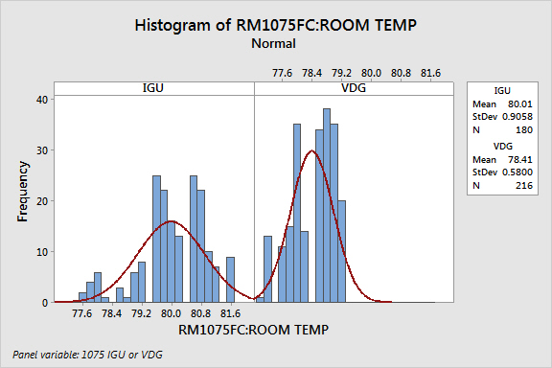

Figure 27: Histogram – Room 1075 RMT, IGU vs. VDG

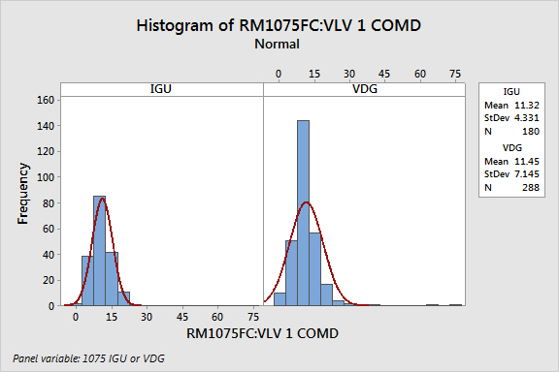

Figure 28 : Histogram – Room 1075 CCV, IGU vs. VDG

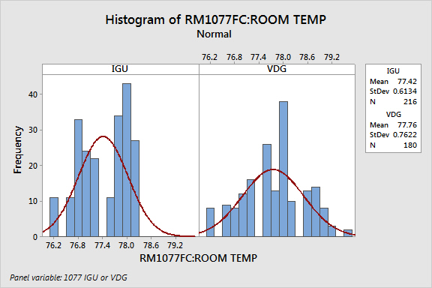

Figure 29 : Histogram – Room 1077 RMT, IGU vs. VDG

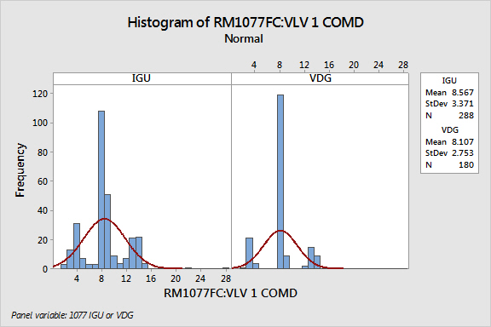

Figure 30: Histogram – Room 1077 CCV, IGU vs. VDG

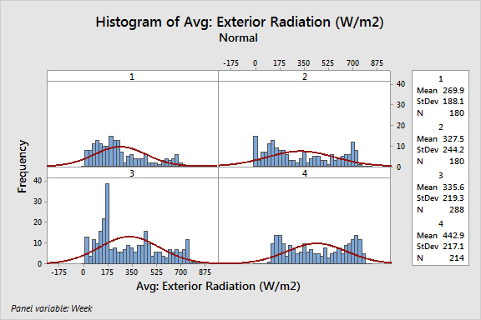

Figure 31: Histogram – Exterior Radiation (W/m2)

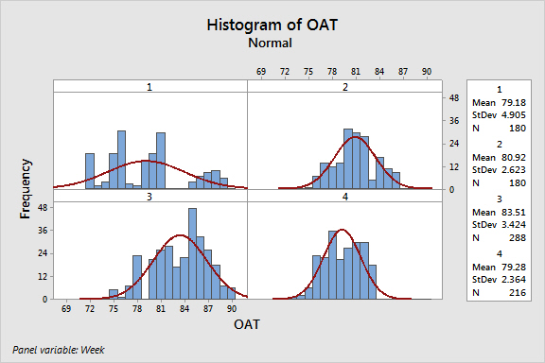

Figure 32: Histogram – Outside Air Temperature

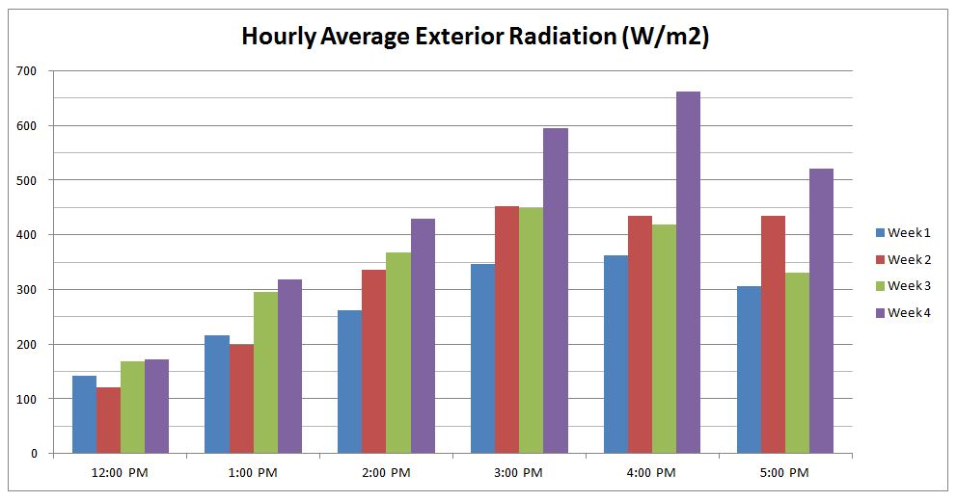

Figure 33: Average Hourly Exterior Radiation, All 4 Weeks

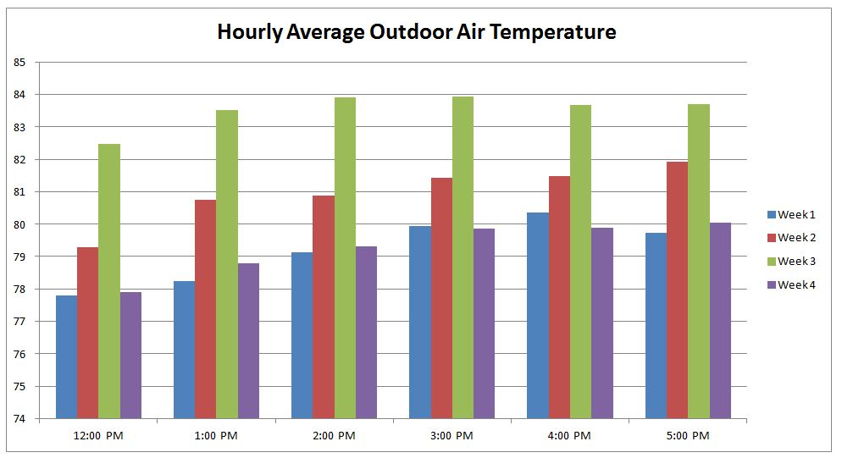

Figure 34: Average Hourly Outside Air Temperature, All 4 Weeks